A000-Am, S-Colombia-Tairona-Tumbaga-Woman seated with backpack, necklace, earrings and headdress-1000-1500 CE

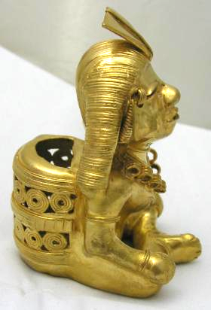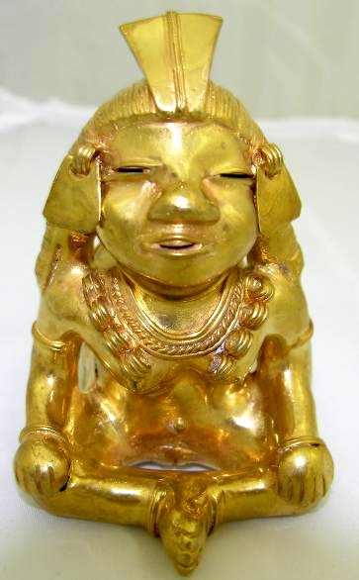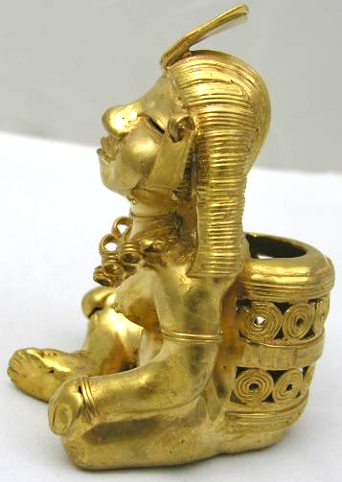

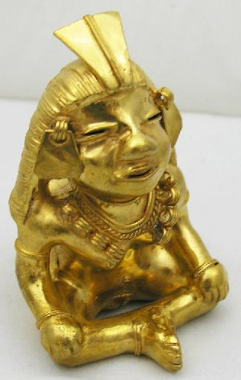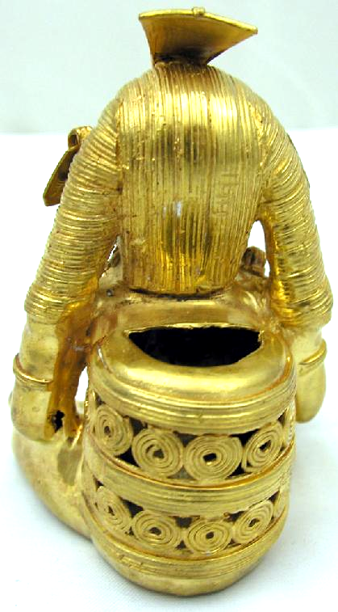

Figs. 1-5. Colombia-Tairona-Tumbaga-Woman seated with backpack, necklace, earrings and headdress-1000-1500 CE

Case No.: 7

**Accession No.**

**Formal Label:**

**Display Description:**

**LC Classification:**

**Date or Time Horizon:**

**Geographical Area:**

**Map:**

**GPS coordinates:**

**Cultural Affiliation:**

**Media:** GOLD, SILVER AND COPPER ALLOY

**Dimensions:** 90 mm x 60 mm

**Weight:** 109.0 GRAMS

**Condition:**

**Provenance:**

**Discussion:**

**References:**